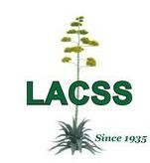
The Los Angeles
Cactus and Succulent Society
Member Badge Form

Member Name(s):
Email:
Best Phone #:
Badges are $10 each

